Shark Hunter Design: Kila Hoali’I (Killer K)

Design
Playstyle
- Kila Hoali’i is intended to be a feral close-range fighter, one that hunts with predatory instinct and savagely takes down prey.
- His abilities are designed to close the distance with other hunters and strike with close range burst damage.
- A movement forward hunter that sacrifices range for close up options.
Primary fire: Ectopic Shotgun
- Fires out a row of teeth in a shotgun blast.
- Damage similar to Prophet or Taurus, if not slightly less due to extra mobility.
- 6 shots.
Secondary fire: Serrated Volley
- Similar to other shotgun hunters a secondary fire can be charged to deal poke damage at mid-range.
- Ammo isn’t fired all at once.
- Ammo is fired in a quick volley, requiring the player to track their opponent for the duration of the shot.
- Medium recoil can be added to increase skill ceiling.
Ability 1: Submerge
- Using their drill like front teeth they burrow underground, only leaving their dorsal fin shaped scope exposed.
- They can move around freely underground whilst the ability is channelled with a slight movement speed increase.
- At any point during submerge, the player can emerge biting directly upwards, dealing damage and vertical knock-up to any player within the attack radius.
- The player can charge their emerge attack to increase both damage and knock-up
- After 6 seconds the ability will end automatically.
- 50 second cooldown.
Ability 2: Shark Attack
- Lunge forward a short distance, biting and dealing damage to any opponent in your path.
- No knockback.
- Can be used whilst channelling Submerge to dolphin dive above ground, take a bite, and re-submerge.
- 2 charges.
- 25 second cooldown.

Narrative
Real name: Koa Akamu
Inception age: 19
Place of Birth: Maui, Hawaiian Islands
Faction: Wildcards
Origin - Tribe
After the people of earth were made aware of the existence of Starfall, many groups realised that space travel would not be a viable method of survival, these groups of “Scrappers” did what they could to utilise technology and form factions with one another. However, some had no such options, that is to say they were robbed of these opportunities by the decisions of their ancestors. One such group was a tribe of Hawaiian natives that vowed off technology in all it’s forms as their chosen method of survival. After working together to build a bunker deep underground they cast away their old lives and awaited apocalypse, choosing to return to their roots and rely on themselves, hunting and gathering for food on the surface once their provisions had swindled away.
Due to this decision and the rapid generational advance (caused by Starfall’s ageing process), their tribe quickly became completely out of touch with the world around them. With no real way of passing knowledge beyond stories and art, the events of Starfall soon became legend and the rapid aging process on the surface was an act of god for taking from mother natures resources to survive. Those immune to the rapid aging were seen to be blessed by god and praised as leaders, it was their responsibility to bear as many children as possible in hopes of passing on this gift.
Origin – Christopher Lupa Herdwick
Not long after the League of Steel was established, many were keen to look for ways to participate, one such person was Christopher Lupa Herdwick. Christopher was a member of one of the Scrappers factions (based in California) obsessed with the Hunters as a way to gain fame, fortune, and most importantly establish a legacy. His obsession bordered on fanatical, but he was not fortunate enough to be born with a mutation to become one, so he dedicated his life to research. After rigorous planning in secret, he needed a subject to make his plans come to fruition, and he intended to procure one at all costs. Using salvaged parts from other hunters as well as resources he had stolen from under the Scrappers nose, he got very close to achieving his goal, however, when he was caught attempting to kidnap a Starfall immune child he was thwarted and quickly pursued off the mainland, where he narrowly made his escape by seacraft.
Left with nothing but his research, and his slapdash hunter, he had all but given up on his plans; accepting that if he did not run out of resources whilst out at sea that he would certainly die soon enough from the effects of Starfall. That was until he made a large discovery when landing his craft on the coast of Hawaii: a tribe of natives that were completely unawares to the going ons outside of their island nation. When Christopher first arrived, the tribe was slow to trust him, a stranger from a far away land piloting a seacraft they had only ever heard stories of. However, he quickly gained their trust with his technological marvels, introducing them to devices and creations that would make their time spent on the surface much better in many ways. So when he told them of what the hunter he had on board his ship could do, they showed him the way to their young new tribe leader: Koa Akamu.
Origin – Koa Akamu
Koa was the newest male leader of his island tribe, proficient in all skills required to survive on the surface, not to mention he was immune to Starfall; needless to say his people saw him as a gift among gifts bestowed by god, someone that could keep the tribe safe and fed for generations. Of his many practical skills, he was particularly skilled in hand to hand combat, it was said that by those who saw him fight “it was as if he was a completely different person, a beast even”. To Christopher, he was the perfect specimen for his project, to Koa, Christopher’s project was the perfect way to fulfil his role as the tribes protector.
Christopher showed him on board his ship, not realising the monster that was lying dormant within Koa. The bestial nature of his fighting was in fact a recessive gene caused by generations of breeding from Starfall immune tribe leaders, something that had been passed on between generations, causing the individual to only have a partial immunity to Starfall: with their body staying alive but their mind feeling the effects of the decay. When his consciousness was transferred the mutation too was passed on to his hunter and the result was a monster of unparallel proportions, a hunter with a foot in two worlds one side a man that only seeked to protect and provide for his tribe, and the other a feral beast that only seeked violence. Koa’s hunter immediately destroyed the ship it was on as soon as it was born, killing Christopher in the process, from there he went out to sea in hopes of finding a worthy opponent.
Origin – Kila Hoali’i
His rampage terrified the tribe initially, many had thought they would die that day, but they soon came to realise that he was not an entity to be feared but rather one to be revered. The part of Koa that wished to protect his tribe would not stray far from the islands, but the restless beast only sought to hunt and fight worthy prey. The mechanised monster would occasionally re-emerge on the island shore, dropping its latest kill; sharks, whales, whatever it could find worth killing. Accepting this new way of life, the people gave their new steel god a name: Kila Hoali’i, a take on the shark god Kamohoali’i, directly translating to Steel King.
Origin – Wildcards
Due to the hush hush nature of almost every element of Kila Hoali’I’s creation, no one really knew they existed but when rumours reached Prophet of a massive beast off the coast of California said to be seen killing a blue whale, he quickly rushed to investigate and what he found did not disappoint. When first attempts to make contact with Kila Hoali’i were made, a fight broke out between them and Prophet, one that lasted days with seemingly no end or victor in sight. However, when Prophet noticed that Kila Hoali’i was intentionally directing the destruction away from the mainland he asked “What do you fight for beast? And do you wish to fight for it more?”, the human within him mustered up a concise but powerful response “I fight for here, I will fight until…I…DIE”.
With that short dialogue, Prophet knew hew was dealing with more than just a beast, but a man he could reason with. He took his opportunity and told Kila Hoali’i all about the league of hunters, a chance to hunt and fight with worthy prey whilst providing for his tribe. The fighting soon subsided, Kila Hoali’i’s choice was clear, to become a Steel Hunter.

Art
Artist Note
All art was offered by my close friend and fellow budding game developer Jamie Mealing, a talented concept artist who leapt at the chance to do some concepts for this project on very short notice. His other works can be found here: (https://www.artstation.com/jombajuice).
Designer Sketches
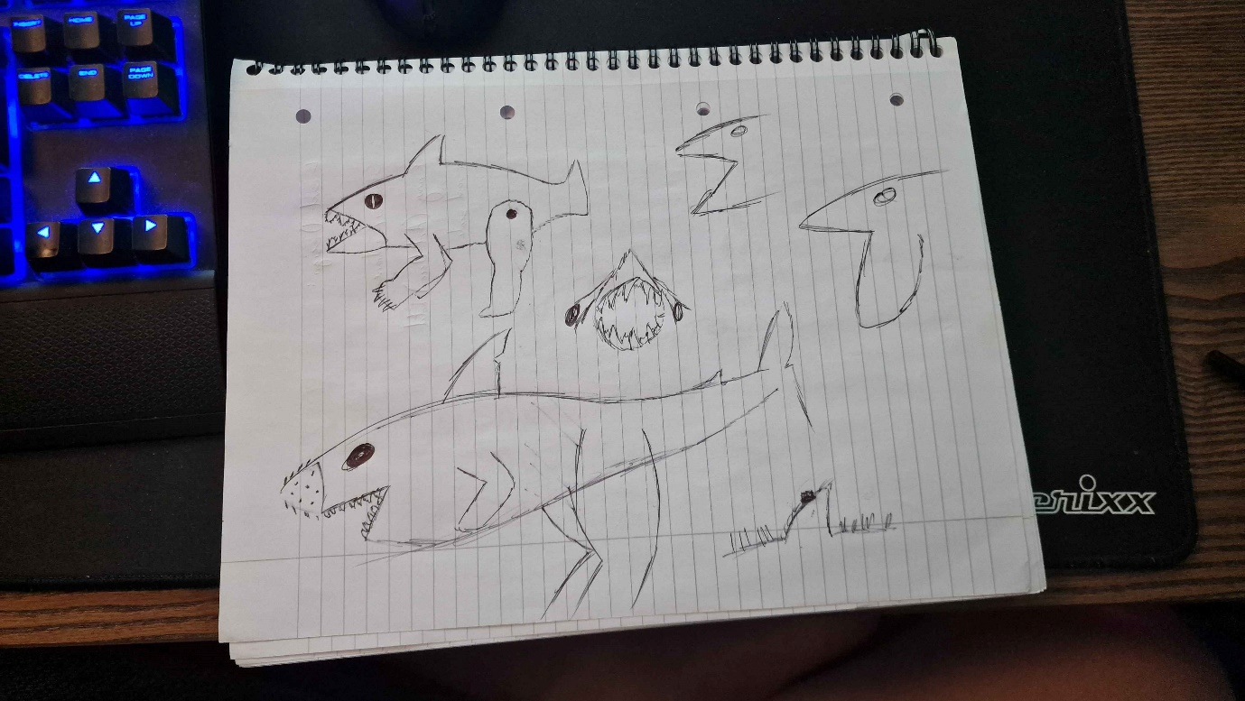
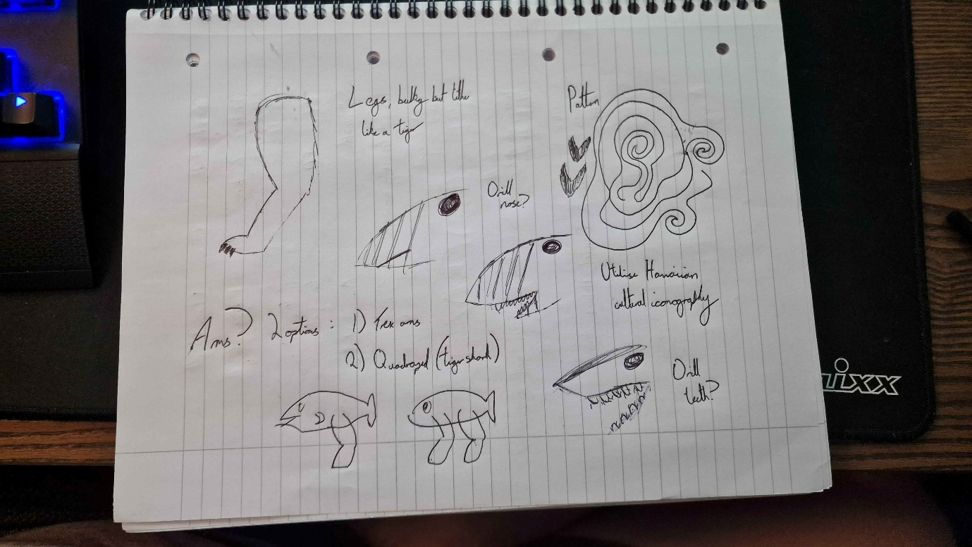
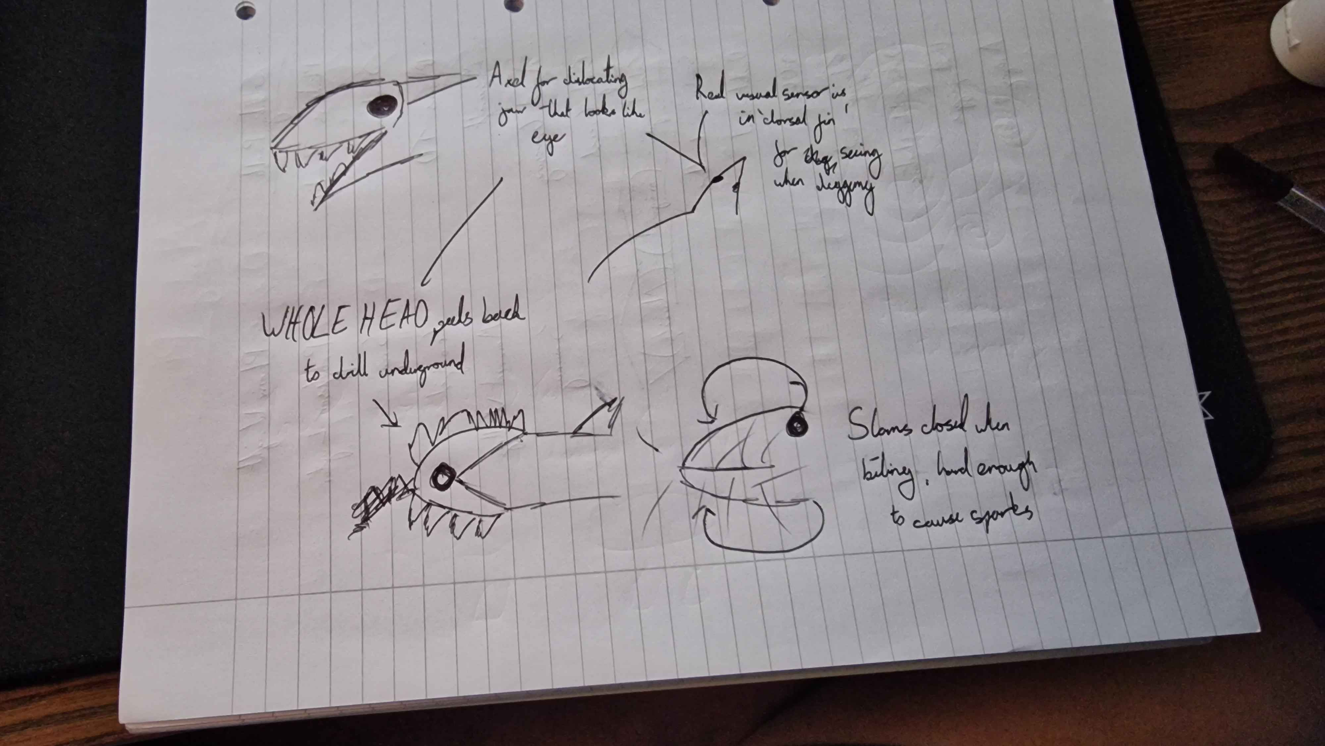

Early Concepts (by Jamie Mealing)
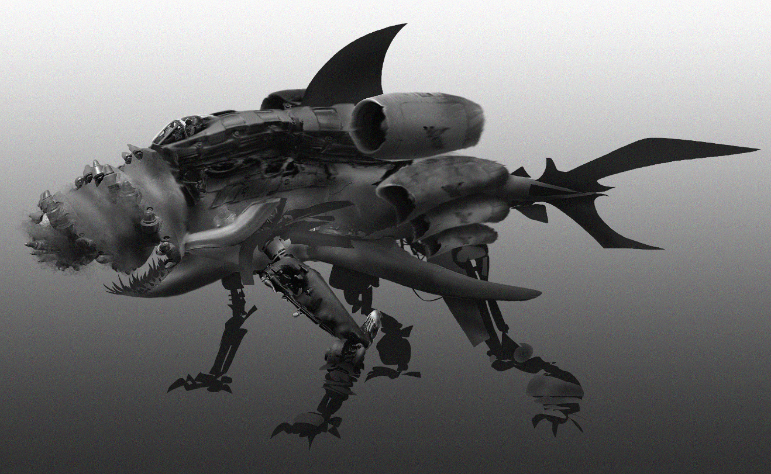
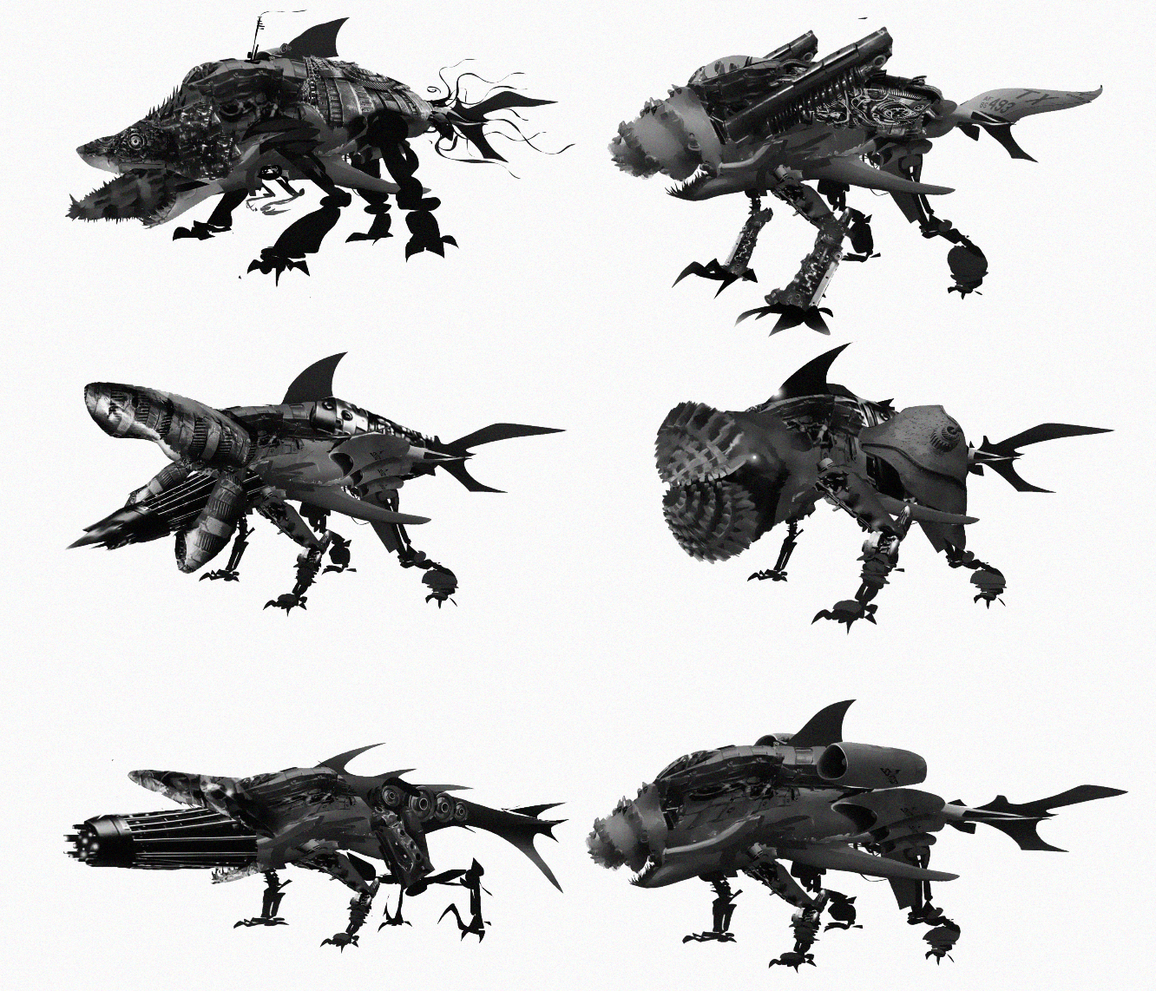
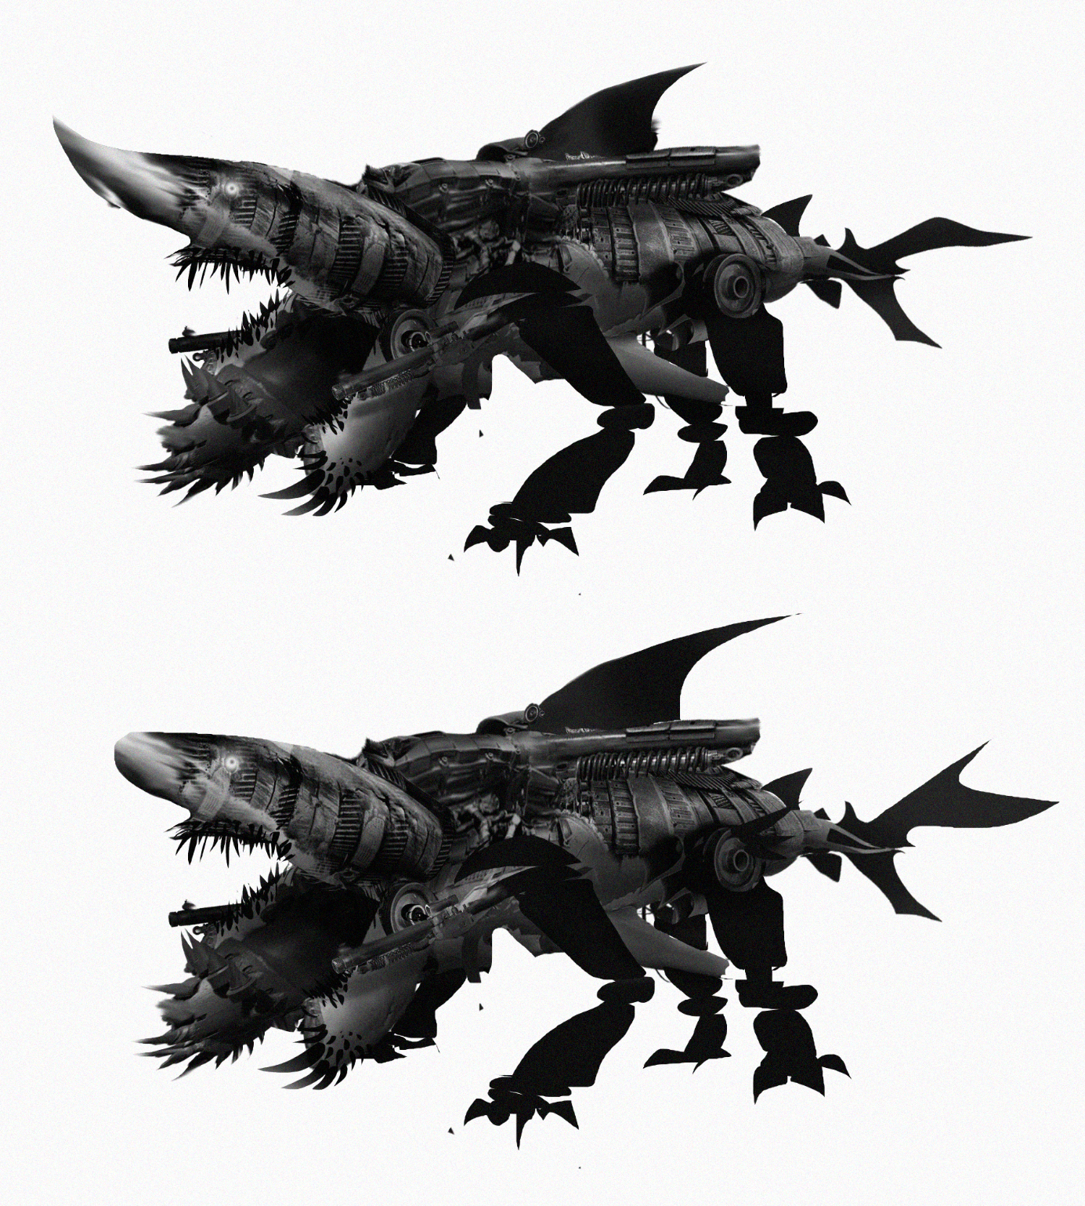

Final Concepts (by Jamie Mealing)
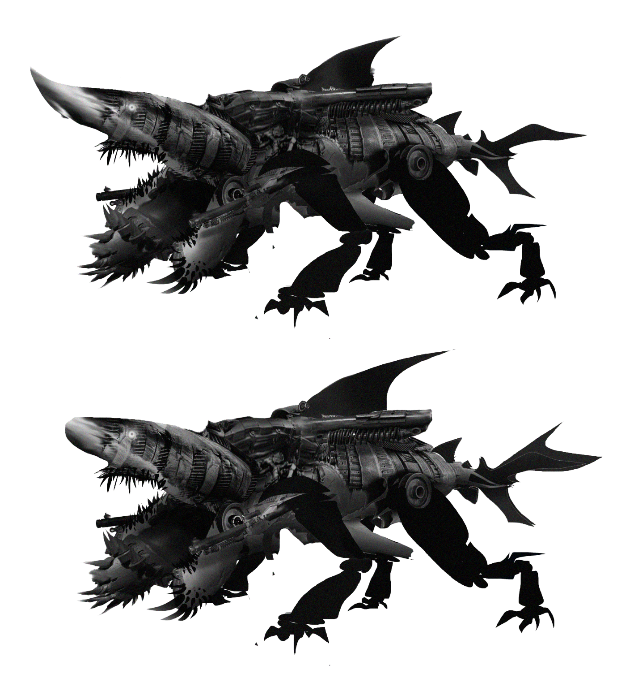

Ability Panel (by Jamie Mealing)
